TITLE WRITTEN IN BOLD AND CAPITAL LETTERS, LESS THAN 20 WORDS
(font : Arial Narrow, size : 12, Bold)

Author Name¹*, Author Name², Author Name³ (font : Arial Narrow, size : 12, Bold)
¹*Corresponding authors' affiliation, with address, include country
²Corresponding authors' affiliation, with address, include country
³Corresponding authors' affiliation, with address, include country
Corresponding author email address : author_mail@address.com

ABSTRACT (English) (font : Arial Narrow, size : 12, Bold, maximum: 250 words) 🡪 unstructured paragraph
In English, translation of Indonesian version of abstract. Abstract consists of Background. Method. Results. Conclusion. (font : Arial Narrow, size 12, line spacing : single). In English, translation of Indonesian version of abstract. Abstract consists of Background. Method. Results. Conclusion. (font : Arial Narrow, size 12, line spacing : single). In English, translation of Indonesian version of abstract. Abstract consists of Background. Method. Results. Conclusion. (font : Arial Narrow, size 12, line spacing : single).

Keywords: Keyword 1; keyword 2; keyword 3 (alphabetical order and font : Arial narrow, size 12, italic)

BACKGROUND (font : Arial Narrow, size : 12, Bold)

Content (font : Arial Narrow, size 12, line spacing : single, alignment : justified, indentation : first line by 0.5)

Contains "Background" and "Research Purpose/aim". This parts should be supported by adequate literature and sources, especially primary references and clearly visible progress of the material under study, so as to see the contribution to the development of nursing science

METHOD (font : Arial Narrow, size : 12, Bold)

Content (font : Arial Narrow, size 12, line spacing : single, alignment : justified, indentation : first line by 0.5)

Methods should be structured (with subheading), including:
*Quantitative Study (Study design, Sample, Instrument, Intervention, Data Collection, Data Analysis, Ethical Consideration)
*Qualitative Study (study design, informants, data collection, data analysis, trustworthiness, ethical consideration)
Study design (Identify the specific research design used, for example if qualitative study like as grounded theory, phenomenology, and ethnography, or for example if quantitative study like as correlational, experimental, quasi-experimental, cross-sectional, and longitudinal study)
Sample/Participants/Informant (the sampling strategy/strategies used, the inclusion and exclusion criteria, explain how participants were recruited, the size of the sample (and the population, if appropriate, report the sample size calculation, or power analysis, if appropriate; if not appropriate or not undertaken, provide another type of justification for the sample size).
Instrument (the source of the instrument, validity and reliability of the instrument, the name of instrument including its citation and reference, how to use the instrument)
Intervention (this heading is only for experimental studies, Explain briefly the process of intervention, setting, and those who did intervention, If you have control group, please explain what kind of intervention you do to them)
Data collection (when and where the data were collected, who collect the data, any research assistants/enumerators/local coordinators?)
Data analysis (the techniques used to analyse the data, including computer software used, if appropriate)
Trustworthiness (this heading is only for qualitative study, Provide types of and estimates for trustworthiness of qualitative data, including types of dependability and credibility used)
Ethical consideration (Provide a statement of ethics committee approval and the complete name of the institution and approval number should be stated in this heading).

RESULT (font : Arial Narrow, size : 12, Bold)
Content (font : Arial Narrow, size 12, line spacing : single, alignment : justified, indentation : first line by 0.5)

To refer a table, please write "(Table 1)"
in the end of the sentence. In the beginning of the sentences, write " Table 1 shows …....". To refer a picture, please write "(Figure 1)" in the end of the sentence, or write "Figure 1 shows...."

Results should reveal and explains the results of research that has been done in the form of tables or pictures obtained.

DISCUSSION
Content (font : Arial Narrow, size 12, line spacing : single, alignment : justified, indentation : first line by 0.5)

The obtained result then discussed by comparing with the results of previous research. Other source of references (of the previous researchs) aimed to strengthens the argumentation of the results of research that has been done. The sources of references in the discussion must meet the scientific requirements (journal, textbook or proceeding). End with study limitations.

CONCLUSION AND RECOMMENDATION
Content (font: Arial Narrow, size 12, line spacing : single, alignment : justified, indentation : first line by 0.5)

Contains on the main subject of the research that has been done in answering the research objectives. Identify implications/recommendations for practice/research/education/management as appropriate, and consistent with the limitations.

REFERENCES
References format by APA (American Psychological Association) 6th Edition with DOI assigned
JKS strongly recommend to use citation tools as Mendeley
If the reference source is in Indonesian then translate the title of the reference source into English
Please use references in the last 10 years

Table content (font : Arrial Narrow, size 10)
Table notes (font : Arrial Narrow, size 12)

Table could submitted as supplementary file when submitting onto JKS website, if the table included in the article kindly put in the text box for easy editing. Every table must have description below the table

Figure

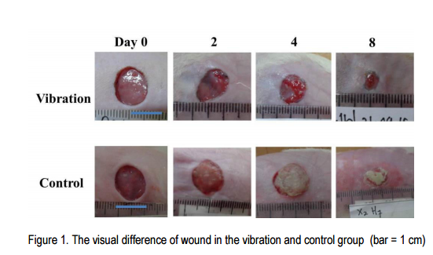

The description of figure is written below the figure
Table 1. Title (font : Arrial Narrow, size 12, bold, position justify)

Note: A: Intervention Group; B: Control Group

